DSC 650 – Big Data

Week 8 Assignment

Eyram Kueviakoe

Screenshot showing ‘mynewcollection’ in the Solr Web Interface

Screenshot showing successful data ingestion messages in the terminal.

Screenshots of the JSON response for both queries.

Query 1:

Query 2:

Screenshots of different queries and their results from the Solr Web Interface.

Number of products in each category

Products in the ‘Electronics’ category.

Products in the ‘Books’ category.

Prices greater than or equal to 50

Create a new collection in Solr

/opt/solr/bin/solr create -c week8_sales_collection

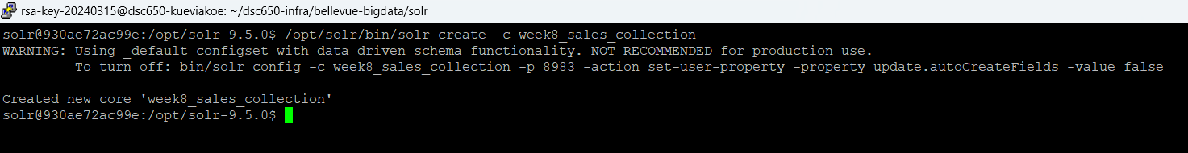

Let's create a json file and call it sales.json

Let’s add the data to the collection

Queries:

All documents from the collection

Sales where category = clothing

Number of sales by category

Category = kitchen

curl "http://localhost:8983/solr/week8_sales_collection/select?q=category:Kitchen"

Total sales price is higher or equal to 650

